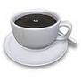


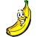
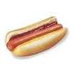
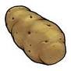
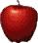
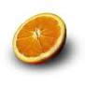
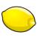
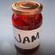
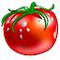
N
F
B
A
P
O
T
A
F
P
P

